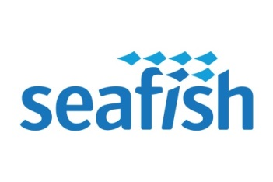


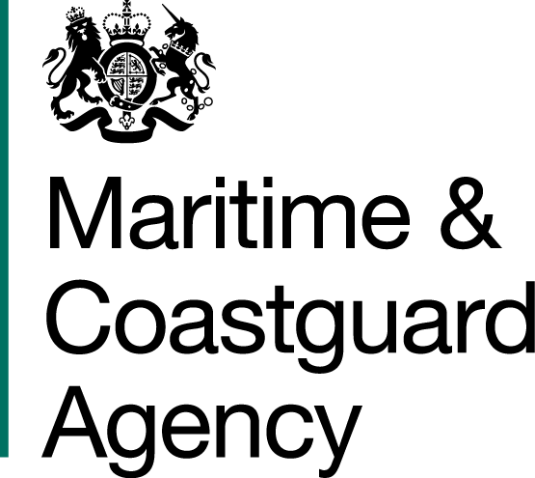

APPLICATION FOR FUNDED TRAINING –
EXPERIENCED FISHER

Complete this form if you are an experienced commercial fisher wanting to apply for funding to undertake voluntary training to refresh or develop your safety knowledge and skills.

Eligibility:

To be eligible for funded training you must:
- be aged 18 or above and have worked as a commercial fisher for at least two years
- have completed all the required basic safety training courses (sea survival, first aid, fire-fighting, health & safety and safety awareness)
- be an experienced commercial fisher who has worked on a UK-registered fishing vessel for at least 60 days within the last two years

How to Apply:

Step 1 - before undertaking the training, you must complete this application form and email it to trainingadmin@seafish.co.uk for approval. We will not fund training retrospectively.

Step 2 - we will check your eligibility for funding (see criteria above) and email you to advise on the outcome of your application within 14 days of receipt.

Step 3 – if your application is approved, you can proceed with booking onto the course(s) for which you have applied; your approval will be valid until the date of your selected course.

Data Protection:

Seafish and its Approved Training Providers have a legal obligation to keep a record of your personal details and any basic safety training that you have completed. Details of what information we hold for you are available on request (email us at trainingadmin@seafish.co.uk or call us on 0131 380 4505 and select option 1). We may contact you from time to time to check and verify your information. We are obliged to share this information with the Maritime & Coastguard Agency and other relevant authorities on request.

We may also share your details with:
- any other training providers you might approach (to enable them to check whether you might be eligible for any funding for training and to inform them what other training you might need to undertake), and
- with the owner, managing agent and/or skipper of the vessel you are working on, or wanting to work on (to confirm to them what training you have completed).
APPLICATION FOR FUNDED TRAINING
1. Personal details (complete all boxes; use capital letters)

Surname:
Forenames:
Date of Birth: |  |  |  |  | Nationality:
UK Residential Address:
Postcode: |  |  |  | Phone Number:
Email address:

Section 2 – Fishing Experience
(Please provide details of your commercial fishing experience over the last two years, starting with your current/most recent vessel)

Vessel Name | Registration Number | Role  (deckhand/skipper) | Dates  (e.g. From – To)

Section 3 – Training Required
Funding is only currently available for training delivered by Seafish Approved Training Providers. Please detail below what training course(s) you want to undertake:

Course | Date | Cost | Provider

Declaration:
“I confirm that all the above information is correct and that I am an experienced commercial fisher working on a UK-registered commercial fishing vessel.”

Signature: |  | Date:

Warning: In the event that any of the information provided is found to be false, the Sea Fish Industry Authority reserves the right to inform the appropriate authorities, including the Maritime and Coastguard Agency.

For official use only:
Date received:
Eligibility Checked/Verified:
Approval number:
Date approval sent:

Sea Fish Industry Authority,
Training Department, Origin Way, Europarc, Grimsby DN37 9TZ
Tel: 0131 380 4504. Email: trainingadmin@seafish.co.uk

